

**SMART TRAP**

**From: SMART Mosquito Trap Team#2**

**To: Dr. Crystal M. Hepp, Dr. Winfree, Ashwija Korenda**

**Date: 2-15-2019**

**Re: Schedule documentation / client contract**

**__________________________________________________________________________**

**Introduction:**

This memo is to inform you of team 2’s schedule and plan of the final project for the remainder of the semester. The memo will go over our critical path and the dependencies, float, and contingencies that highlight the path to the overall completion of the final project. The memo will then go over the schedule for the semester. This schedule will be represented with a gantt chart and be further elaborated in detail as to when meeting times/important due dates will be met. The memo will the go cover not only our expectations but the expectations of Dr. Hepp regarding the final project.

**Schedule documentation:**

For this semester, our ultimate goal is to successfully build and test the power supply for the smart mosquito trap. For our part we must build a system that will supply the trap with enough power to live off of in a remote setting for up to a week. As a team, we have come up with a critical path containing 3 major phases: The design phase, build phase, and the test phase. These 3 phase are critical in the successful completion of our project. The design phase is where we have created the circuit and the housing that will be connected to team 1’s design. The building phase is where we will actually build the circuit. We will do this by placing all the elements onto the PCB and the solder them onto the board. We will then fit this circuit into the housing. The housing will have to be modified to withstand all kinds of weather conditions, display crucial data of the circuit, and have ports that power team 1’s design. The testing phase will encompass both indoor and outdoor settings for the final tests. The indoor test will be used to measure and analyze certain parts of the circuit board. After everything has been been teste and made sure of its performance, we will move into outdoor testing. Outdoor testing will test its remote powering capabilities. We will leave it in the field for a week and test it to makes sure that it works properly with team 1’s portion of the project.

**Team communication strategy:**

Ino der to make sure every aspect of the design is completed and that we meet important deadlines, we created a gantt chart that will layout every major due date and critical path for our project. This gantt chart contains our 3 phases, team/GTA meeting dates, and miscellaneous deadlines highlighted in the semester syllabus.

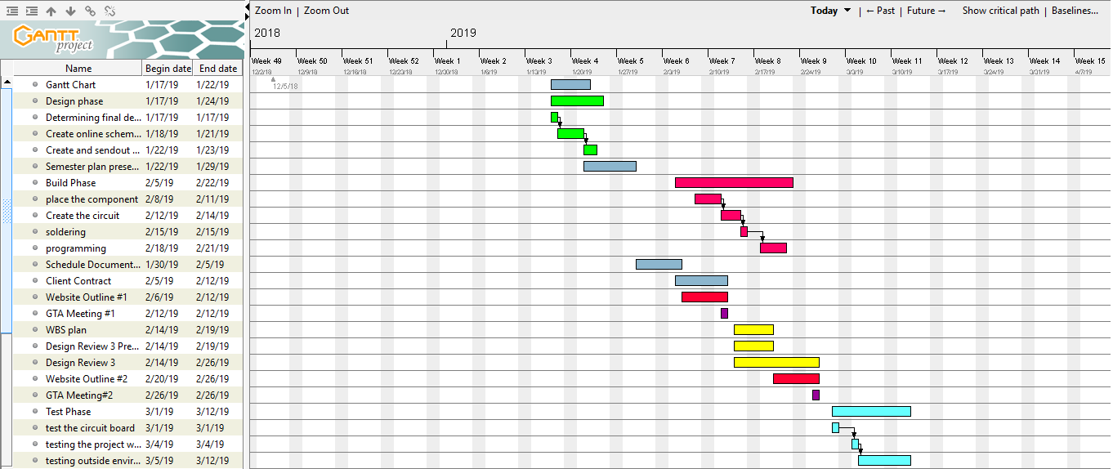

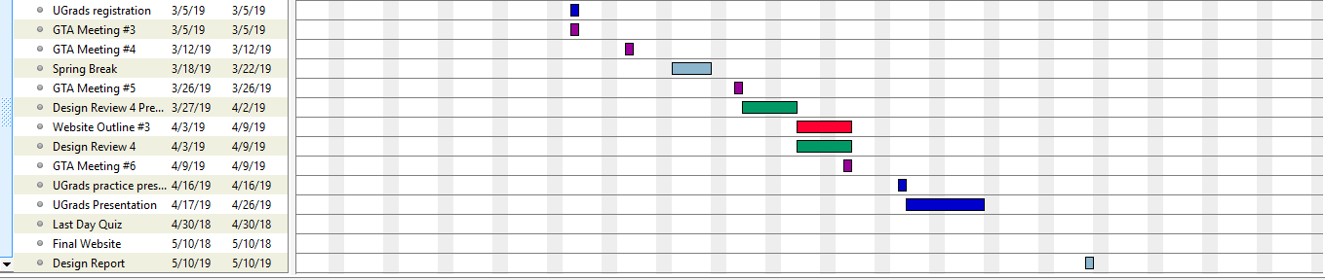

**Figure 1: Gantt Chart**

The gantt chart gives an overview of our schedule for the rest of the semester the critical path follows 3 phases and the different colors highlight all of the different sub-tasks.



**Figure 2: Design Phase**

The figure above illustrates our schedule for what we expect to be the designing portion of our project. This phase includes creating the schematic for our solar charger and designing the box that will encapsulate the circuit.



**Figure 3: Build Phase**

This phase includes the actual building of the solar charger. We will be soldering all of the parts onto the PCB and building the weather proof casing for the circuit.



**Figure 4: Test Phase**

In this phase, we will be testing the solar charger indoors to make sure everything works as planned After testing in a controlled environment, we will then take it outside to make sure that it works with all of the elements.

As you can see above, our gantt chart contains everything that will be due and that pertains to the project for the next couple of months. We created this gantt chart with delays and other possible “bumps in the road” in mind. We moved our critical path deadlines up so that in case anything were to fail or not go as planned we would still complete everything by the end of the semester. As a team we decided that meeting once a week is a an appropriate and logical expectation for this semester. We decided that Thursdays would be best for us. The plan is to meet with our GTA and discuss the project and then our client to catch them up on the progress of the project, and then work on things that are due and plan for the building and testing of the project after both meetings. We use texting and emails to communicate between each other, our GTA, and client. This base has some flexibility when it comes to rescheduling and and meeting up more than once a week. Being in the same major, we have common expectations for each other and know what each and everyone of us can and cannot do it when it comes to doing their part in the project.

**Client expectations:**

During the previous semester we met with our client and GTA to not only discuss the project but what will be expected of us. This semester, we have expectations we have to meet in order for the project to be successful in its purpose. Thes expectations will be highlighted below:

* We must build a system that will supply power to team 1’s design
* The system must be powered primarily through solar
* The system must have a backup power bank for nighttime use and emergency use
* The system must be able to be fully functioning for up to a week without any support form the user
* The system must be weatherproof and be able to work in all kinds of terrain
* The system needs to have the capability to hide on a tree while the solar panel can get enough sunlight to charge the backup battery and and supply power to the trap

Signature:__________________________________

These expectations were previously discussed with our client and GTA and set as the standards we as a team would meet. Both parties have agreed that these are appropriate and reasonable expectations for our team. The goal as stated earlier is to create a function solar charger that will supply power to the mosquito trap and charge the backup power bank.

**Conclusion:**

This memo hopefully outlined the projected schedule and expectations for the rest of the semester. We first went over our schedule and how we organized in a way that made sense to every team member so that that deadlines could be met successfully and on time. We then went over the schedule itself and highlighted the critical path of our gantt chart. The critical path illustrated the important parts of our schedule and what we will need to follow in order to complete the project and meet expectations. Finally, we went over the expectations that we decided on with our GTA and client. These expectations are organized in bullet format so that they were clear for both parties involved. This memo should give a clear and in depth idea of what to expect in the coming months and what will be completed by the end of the semester.